Practical Number 6: Create a webpage that demonstrates the use of data bound controls of ASP.NET.

Data Controls:

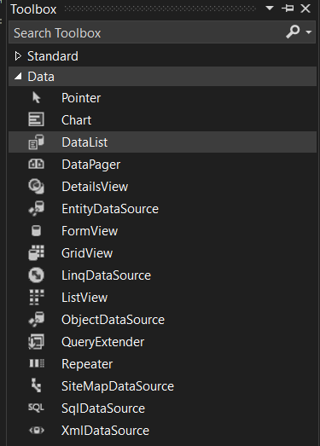

DataGridView:

